**WOMENS CHRISTIAN COLLEGE, NAGERCOIL**

**DEPARTMENT OF COMMERCE**

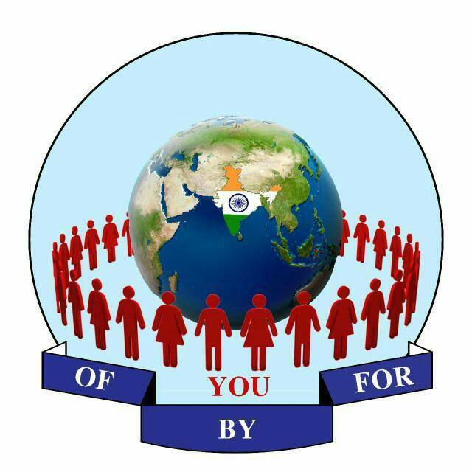



**Organises**

**SEMINAR**

**ON**

**ENTREPRENEURSHIP**

**07.02.2020**

**NEED OF THE SEMINAR**

The seminar entitled “Entrepreneurship” is to create entrepreneurs. Entrepreneurs take the economy and the society to the state of progress and prosperity. Entrepreneurship is the dynamic process of creating incremental wealth and innovating things of value that have a bearing on the welfare of an entrepreneur. It provides civilization with an enormous amount of goods and services and enhances the growth of social welfare. The main importance of entrepreneurship is the creation of job opportunities, innovation, and improvement of the economy. New products and services created by entrepreneurs can produce a cascading effect, where it stimulates related businesses or sectors that need to support the new venture, furthering economic development.

**WHO CAN PARTICIPATE**

UG AND PG students of Arts and Science stream

**REGISTRATION FEE**

Rs.50/- for each participants

(Registration fee includes Refreshment and Certificates only)

**CONTENT OF THE SEMINAR**

Who is an Entrepreneur?

How to become an Entrepreneur?





Guidelines for “Young Entrepreneurs Award Program”

**CONDUCTED BY**

**CAPE RESEARCH FORUM**

**OF, BY AND FOR – YOU TRUST**

Trust.Reg.No.198/ B4 - 2017

Nagercoil, Kanyakumari Dist.

